



**Department of Computer Science**

**Quaid-e-Azam University, Islamabad**

**Assignment 3**

**Student Course Registration System**

Prepared by:

**HURR MEHDI**

**M. SEHAL BILAL**

**M. ASAD (Leader)**

**ZOHAIB AHMED**

Submitted to:

**DR. ONAIZA MAQBOOL**

17 March 2025

|  |  |
| --- | --- |
| Use case Description & System Sequence Diagram | **Student Course Registration System** |
| Created by | Hurr Mehdi (04072312048) |
| Date Created | 17-03-2025 |

## Use Case: View Academic Progress

**Primary Actor(s):**

* *Student*

**Use Case Description:**

*This use case allows a student to view their academic progress, including courses they have passed, failed, and pending requirements.*

**Stakeholders and Interests:**

* *Student: Wants to track their academic performance and plan future registrations.*
* *University Administration: Ensures accurate record-keeping and compliance with academic policies.*
* *Course Coordinator: Uses progress data to advise students and update curriculum requirements.*

**Preconditions:**

* *The student must be logged into the system.*
* *The student’s academic records (course registrations, grades) must exist in the system.*

**Postconditions:**

* *The student’s academic progress is displayed.*
* *No changes are made to the database (read-only action).*

**Inputs:**

* *StudentID*

**Outputs:**

* *AcademicProgressDetails (passed courses, failed courses, pending prerequisites, GPA).*

**Main Success Scenario:**

* *The student navigates to the Academic Progress section.*
* *The system retrieves the student’s academic records (registrations, grades, prerequisites).*
* *The system generates a summary of:*
* *Passed Courses: Courses marked as "Pass."*
* *Failed Courses: Courses marked as "Fail."*
* *Pending Requirements: Prerequisites not yet completed.*
* *The system displays the academic progress summary to the student in a tabular or visual format.*
* *The student reviews the information and exits the section.*

**Alternative Scenarios:**

* *No Academic Records Found:*

*The system displays a message: “No academic records available. Please register for courses first.”*

* *Technical Failure:*

*If the system fails to retrieve data, an error message is displayed: “Unable to load academic progress. Please try again later.”*

**Sequence Diagram: View Academic Progress**

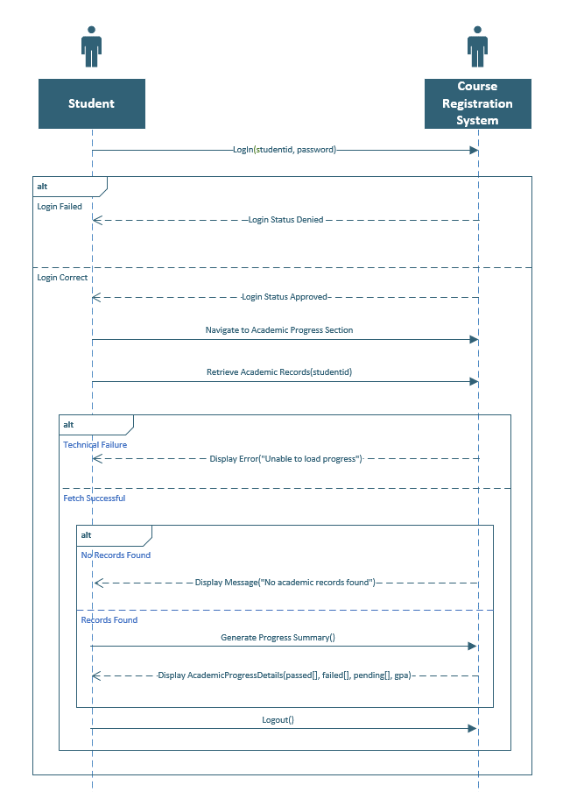

## UML Diagram

|  |  |
| --- | --- |
|  | The purpose of this use case diagram is to provide a visual representation of the functional requirements and interactions between users (actors) and the Student Course Registration System, as outlined in Case Study #3. It identifies key actors, their primary use cases, and the relationships between them.This use case diagram was designed using Argo UML, a UML modeling tool, to adhere to ensure clarity in system design. It serves as a foundational blueprint for upcoming development phases. |

## 

## Actors and Use Cases

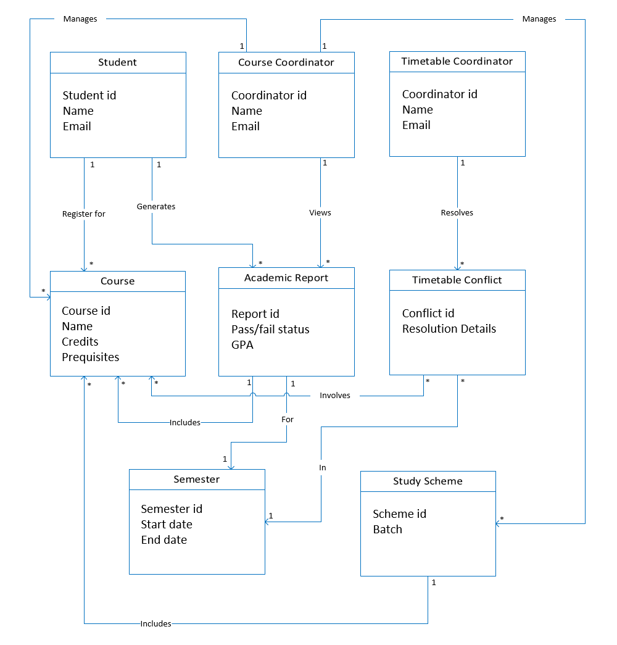

|  |  |
| --- | --- |
| Domain Model | **Student Course Registration System** |
| Created by | Group 8 |
| Date Created | 17-03-2025 |